**SMART MONITERING SYSTEM**

A Course project report submitted

in partial fulfilment of requirement

of

**SMART SYSTEM DESIGN**

by

1. **Shiva Priya (19K41A04A9)**
2. **Vaishnavi (19K41A0494)**

**D.Nihal Raj (19K41A0497)**

**A.Rahul (19K41A0490)**

Under the guidance of

**Mr.Ch. Rajendra Prasad**

Assistant Professor, Department of ECE



1

**ABSTRACT**

Our project is based on safe monitoring system in industries. The sensors we used are PIR sensor , temperature sensor(LM35) and also gas sensor, and the actuators used are relay, buzzer and LCD.

Here the flame is produced to manufacture a product, the temperature sensor is used for intimating the limit of flame(temperature of the flame). we have set 500C, is the limit, if the temperature crosses 500Cthe buzzer gets on and gives alert. When flame is produced, there is some gas released through it, the gas sensor detects the dangerous gases present in the smoke released. And gives a display on LCD. As this process is an unsafely and dangerous for the labour working in the industry.we have arranged a boundary ,to which PIR sensor is connected. This detects the motion of a person or human and sends the information to the arduino , which gets displayed on LCD to give alerts and glows the bulb through the connection with relay actuator.

2

**CONTENTS**

**Abstract ii**

**Chapter No. Title Page No.**

**1 INTRODUCTION**

1.1 About the project 4

1.2 Overview of project 4

1.3 Objective 5

**2 Project description**

2.1 Block diagram of project 5

2.2 Description of block diagram 6

2.3 Hardware description 6

2.3.1 arduino

TEMPERATURE SENSOR 7

2.3.2 PIR SENSOR 8

2.3.4 gas sensor 9

BUZZER 10

RELAY 11

LCD 11

Software description 13

**3.** **CIRCUIT DIAGRAM AND DESCRIPTION**

3.1 Working 14

3.2 Experimental results 15 3.3 Advantages 16

3.4 Disadvantages 16

**4. CONCLUSION**

4.1 Conclusion 17

4.1 future scope 18

4.3 appendix 21

3

**CHAPTER-1**

**INTRODUCTION**

**1.1 INTRODUCTION**

In this present senario, when we come to the process which is going on in industries, there are many dangers and simultaneously damages occured if something goes wron there is more loss of machionery and capital because Industrial processes are procedures involving chemical, physical, electrical or mechanical steps to aid in the manufacturing of an item. Industries are part of the secondary activity. Secondary activities or Industry refers to economic activities concerned with the production of goods, extraction of services and provision or services.

This device SMART MONITERING SYSTEM can intimate or explain the user whats happening in the industry and also give alerts to the labour or user whether something is going wrong or there is any disturbance occured. This device gives indications on display when there is an increase in temparature more than the set or required limti. And also if the temp is above the set limit it gets a rythemic sound by buzzering so that the user can hear the sound and get alerted to take the safety measures. so that there is no damage caused in the process

And while manufacturing of products in industries, there will be production of smoke and also sometimes which may be the dangerous gases. This device detects the harmulful or poisinous gases released during the process and gives a prior indication to the user by displaying on lcd and also by getting the buzzer on. And during this process if there are any labour or people or human coming close, there is an strong indication on lcd to get display and the also there is glow in bulb.

**Advantages:**

* This device reduces the cause of dangers and damages during the process happening in the indutry , by giving a prior indication to the user of the device.
* It stops if any unwanted disturbances occurred
* It is friendly to the user, also which helps the user in many ways.
* Ease of access: can move it easily.

**Disadvantages:**

* If the donot work properly, this project has no use.
* buzzer sound can annoy the users.
* fragile and needs to be taken a good care.

**1.2 OVERVIEW OF PROJECT**

* As the world is fast it also needs its utility’s to be smart enough to keep the speed and help our daily need for us and for the quickest results.
* The user can get a full benefit from even a small danger or any disturbance detected, every part of the piece to be useful.

4

* The user can have the liberty to change the settings of the product and can also increase the security level of accidents occuring in the industry by its positioning.
* User can have an automated life an healthy life.

**1.3 OBJECTIVES**

The objective of this project is to implement a safe, secure, healthy and automated monitering system for the users in industry. which detects the dangers and intimate people some safety and healthy measures.

**CHAPTER – 2**

**PROJECT DESCRIPTION**

**2.1 BLOCK DIAGRAM**

ARDUINO

UNO

LCD,BUZZER

TEMPERATURE SENSOR

LCD,BUZZER

GAS SENSOR

LCD,RELAY

PIR SENSOR

**BLOCK DIAGRAM**

**2.2 DISCRIPTION OF BLOCK BIAGRAM**

From the diagram it mainly consists of an Arduino, three sensors, one piezo buzzer, lcd and relay. The three sensors are PIR sensor, Gas sensor and temperature sensor. These sensors are connected to Arduino. When the temperature sensor detect whether the temperature is exceeding the limit provided it will immediately send this information to the Arduino board, then there is display on lcd and on of buzzer. Next is GAS sensor, when the gas released is detected by this sensor and also gives information to display on lcd and get buzzering.

5

Finally, is PIR sensor it detects movement of people or objects near the product and sends an information to Arduino board and then it gives an indication on LCD and reminds the user with a buzzer.

**2.3 HARDWARE DISCRIPTION**

**2.3.1** **ARDUINO UNO**

The Arduino Uno is an open-source microcontroller board based on the Microchip ATmega328P microcontroller and developed by Arduino.cc.[2][3] The board is equipped with sets of digital and analog

input/output (I/O) pins that may be interfaced to various expansion boards (shields) and other circuits.[1] The board has 14 digital I/O pins (six capable of PWM output), 6 analog I/O pins, and is programmable with the Arduino IDE (Integrated Development Environment), via a type B USB cable.[4] It can be powered by the USB cable or by an external 9-volt battery, though it accepts voltages between 7 and 20 volts. It is similar to the Arduino Nano and Leonardo.[5][6] The hardware reference design is distributed under a Creative Commons Attribution Share-Alike 2.5 license and is available on the Arduino website. Layout and production files for some versions of the hardware are also available.

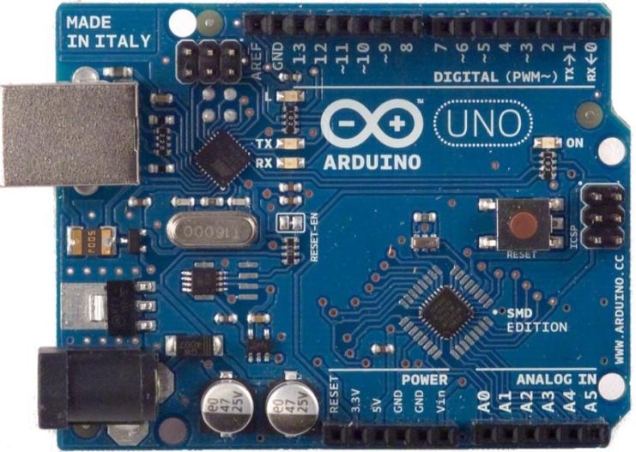

**Fig: 2.3.1 ARDUINO UNO**

**Applications:**

* Xoscillo, an open-source oscilloscope
* Arduinome, a MIDI controller device that mimics the Monome
* OBDuino, a trip computer that uses the on-board diagnostics interface found in most modern cars
* Gammadion, an Arduino shield to create retro 2D video games
* Arduino Phone, a do-it-yourself cell phone
* Water quality testing platform
* Automatic titration system based on Arduino and stepper motor
* Low-cost data glove for virtual reality applications
* Impedance sensor system to detect bovine milk adulteration
* Homemade CNC using Arduino and DC motors with close loop control by Homofacien.

**6**

**TEMPERATURE SENSORS:**

1. **LM35 SENSOR:**

Minimum and Maximum Input Voltage is 35V and -2V respectively. Typically 5V.

Can measure temperature ranging from -55°C to 150°C

Output voltage is directly proportional (Linear) to temperature (i.e.) there will be a rise of 10mV (0.01V) for every 1°C rise in temperature.

±0.5°C Accuracy

Drain current is less than 60uA

Low cost temperature sensor

Small and hence suitable for remote applications

Available in TO-92, TO-220, TO-CAN and SOIC package

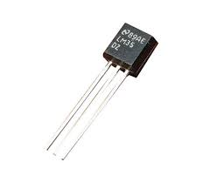

**2.THERMO RESISITOR:**

The Thermistor is another type of temperature sensor, whose name is a combination of the words THERM-ally sensitive res-ISTOR. A thermistor is a special type of resistor which changes its physical resistance when exposed to changes in temperature.Thermistors are generally made from ceramic materials such as oxides of nickel, manganese or cobalt coated in glass which makes them easily damaged. Their main advantage over snap-action types is their speed of response to any changes in temperature, accuracy and repeatability.

Most types of thermistor’s have a Negative Temperature Coefficient of resistance or (NTC), that is their resistance value goes DOWN with an increase in the temperature, and of course there are some which have a Positive Temperature Coefficient, (PTC), in that their resistance value goes UP with an increase in temperature.

**3.RESISTIVE TEMPERATURE DETECTORS (RTD):**

Another type of electrical resistance temperature sensor is the Resistance Temperature Detector or RTD. RTD’s are precision temperature sensors made from high-purity conducting metals such as platinum, copper or nickel wound into a coil and whose electrical resistance changes as a function of temperature, similar to that of the thermistor. Also available are thin-film RTD’s. These devices have a thin film of platinum paste is deposited onto a white ceramic substrate.Resistive temperature detectors have positive

7

temperature coefficients (PTC) but unlike the thermistor their output is extremely linear producing very accurate measurements of temperature.

However, they have very poor thermal sensitivity, that is a change in temperature only produces a very small output change for example, 1Ω/oC.The more common types of RTD’s are made from platinum and are called Platinum Resistance Thermometer or PRT‘s with the most commonly available of them all the Pt100 sensor, which has a standard resistance value of 100Ω at 0oC. The downside is that Platinum is expensive and one of the main disadvantages of this type of device is its cost.

**4.THERMOCOUPLE:**

The Thermocouple is by far the most commonly used type of all the temperature sensor types. Thermocouples are popular due to its simplicity, ease of use and their speed of response to changes in temperature, due mainly to their small size. Thermocouples also have the widest temperature range of all the temperature sensors from below -200oC to well over 2000oC. Thermocouples are thermoelectric sensors that basically consists of two junctions of dissimilar metals, such as copper and constantan that are welded or crimped together.

One junction is kept at a constant temperature called the reference (Cold) junction, while the other the measuring (Hot) junction. When the two junctions are at different temperatures, a voltage is developed across the junction which is used to measure the temperature sensor as shown below.

Thermocouple Construction

thermocouple temperature sensor

The operating principal of a thermocouple is very simple and basic. When fused together the junction of the two dissimilar metals such as copper and constantan produces a “thermo-electric” effect which gives a constant potential difference of only a few millivolts (mV) between them. The voltage difference between the two junctions is called the “Seebeck effect” as a temperature gradient is generated along the conducting wires producing an emf. Then the output voltage from a thermocouple is a function of the temperature changes

**2.3.2 PIR SENSOR**

A passive infrared sensor (PIR sensor) is an electronic sensor that measures infrared (IR) light radiating from objects in its field of view. They are most often used in PIR-based motion detectors.

A PIR sensor can detect changes in the amount of infrared radiation impinging upon it, which varies depending on the temperature and surface characteristics of the objects in front of the sensor. When an object, such as a person, passes in front of the background, such as a wall, the temperature at that point in the sensor's field of view will rise from room temperature to body temperature, and then back again. The sensor converts the resulting change in the incoming infrared radiation into a change in the output voltage, and this triggers the detection. Objects of similar temperature but different surface characteristics may also have a different infrared emission pattern, and thus moving them with respect to the background may trigger the detector as well.

8

**Security Alarm System based on PIR sensor:**

When used as part of a security system, the electronics in the PIR typically control a small relay. This relay completes the circuit across a pair of electrical contacts connected to a detection input zone of the burglar alarm control panel. The system is usually designed such that if no motion is being detected, the relay contact is closed—a 'normally closed' (NC) relay. If motion is detected, the relay will open the circuit, triggering the alarm; or, if a wire is disconnected, the alarm will also operate.

**PIR Sensor based Automatic Door Opening System:**

The main aim of this project is to opening and closing of doors, in places wherein a person’s presence is mandatory – for instance, hotels, shopping malls, theatres.

#### Human Detection Robot Using PIR Sensor:

#### The human detection robot using PIR sensor mainly detects human, and it is based on an 8-bit microcontroller.

#### PIR Sensor based Stepper Motor Control

The main goal of this project is to control a stepper motor using PIR sensor. This project is mainly based on the robotic technology. This technology is mainly used for advanced applications.

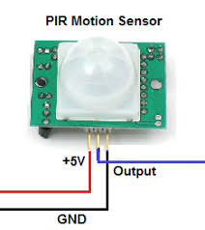

Fig :2.3.2 PIR SENSOR

**2.3.4 GAS SENSOR**

A **gas detector** is a device that detects the presence of gases in an area, often as part of a safety system. This type of equipment is used to detect a gas leak or other emissions and can interface with a control system so a process can be automatically shut down. A gas detector can sound an alarm to operators in the area where the leak is occurring, giving them the opportunity to leave. This type of device is important

because there are many gases that can be harmful to organic life, such as humans or animals.

Gas detectors can be used to detect combustible, flammable and toxic gases, and oxygen depletion. This type of device is used widely in industry and can be found in locations, such as on oil rigs, to monitor manufacture processes and emerging technologies such as photovoltaic. They may be used in firefighting.

9

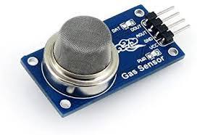

Fig: 2.3.4 GAS SENSOR

**2.3.6 BUZZER**

The piezo buzzer produces sound based on reverse of the piezoelectric effect. The generation of pressure variation or strain by the application of electric potential across a piezoelectric material is the underlying principle. These buzzers can be used alert a user of an event corresponding to a switching action, counter signal or sensor input. They are also used in alarm circuits.

**Types of buzzers: Electromechanical:**

Early devices were based on an electromechanical system identical to an electric bell without the metal gong. Similarly, a relay may be connected to interrupt its own actuating current, causing the contacts to buzz. Often these units were anchored to a wall or ceiling to use it as a sounding board. The word "buzzer" comes from the rasping noise that electromechanical buzzers made.

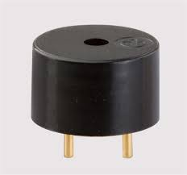

fig 2.3.6.1 Electromechanical buzzer

**Mechanical:**

A joy buzzer is an example of a purely mechanical buzzer. They require drivers.

10

**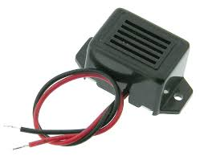**

fig 2.3.6.2 Mechanical buzzer

**Piezoelectric:**

A piezoelectric element may be driven by an oscillating electronic circuit or other audio signal source, driven with a piezoelectric audio amplifier. Sounds commonly used to indicate that button has been pressed are a click, a ring or a beep.

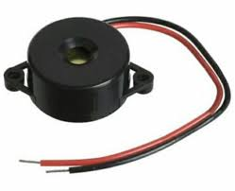

**Fig 2.3.6.3 Piezoelectric buzzer**

**Applications:**

While technological advancements have caused buzzers to be impractical and undesirable, there are still instances in which buzzers and similar circuits may be used. Present day applications include:

* Novelty uses
* Judging panels
* Educational purposes
* Annunciator panels
* Electronic metronomes
* Game show lock-out device
* Microwave ovens and other household appliances
* Sporting events such as basketball games

**11**

**2.3.7 Relay**

A relay is an electrically operated switch. It consists of a set of input terminals for a single or multiple control signals, and a set of operating contact terminals. The switch may have any number of contacts in multiple [contact forms](https://en.wikipedia.org/wiki/Electrical_contact" \l "Contact_form), such as make contacts, break contacts, or combinations thereof.

Relays are used where it is necessary to control a circuit by an independent low-power signal, or where several circuits must be 16 controlled by one signal. Relays were first used in long-distance [telegraph](https://en.wikipedia.org/wiki/Electrical_telegraph) circuits as signal repeaters: they refresh the signal coming in from one circuit by transmitting it on another circuit. Relays were used extensively in telephone exchanges and early computers to perform logical operations.

The traditional form of a relay uses an [electromagnet](https://en.wikipedia.org/wiki/Electromagnet) to close or open the contacts, but other operating principles have been invented, such as in [solid-state relays](https://en.wikipedia.org/wiki/Solid-state_relay) which use [semiconductor](https://en.wikipedia.org/wiki/Semiconductor) properties for control without relying on [moving parts](https://en.wikipedia.org/wiki/Moving_parts). Relays with calibrated operating characteristics and sometimes multiple operating coils are used to protect electrical circuits from overload or faults; in modern electric power systems these functions are performed by digital instruments still called [protective relays](https://en.wikipedia.org/wiki/Protective_relay).

**LCD:**

Stands for "Liquid Crystal Display." LCD is a flat panel display technology commonly used in TVs and computer monitors. It is also used in screens for mobile devices, such as laptops, tablets, and smartphones.LCD displays don't just look different than bulky CRT monitors, the way they operate is significantly different as well. Instead of firing electrons at a glass screen, an LCD has backlight that provides light to individual pixels arranged in a rectangular grid. Each pixel has a red, green, and blue RGB sub-pixel that can be turned on or off.

When all of a pixel's sub-pixels are turned off, it appears black. When all the sub-pixels are turned on 100%, it appears white. By adjusting the individual levels of red, green, and blue light, millions of color combinations are possible.

NOTE: An LCD's backlight may either be a traditional bulb or LED light. An "LED display" is simply an LCD screen with an LED backlight. This is different than an OLED display, which lights up individual LEDs for each pixel. While the liquid crystals block most of an LCD's backlight when they are off, some of the light may still shine through (which might be noticeable in a dark room). Therefore OLEDs typically have darker black levels than LCDs

**2.4 SOFTWARE DESCRIPTION**

The software used is “TINKERCAD”.

**Tinker cad** is a free, online 3D modeling program that runs in a web browser, known for its simplicity and ease of use. Since it became available in 2011 it has become a popular platform for creating models

for [3D printing](https://en.wikipedia.org/wiki/3D_printing) as well as an entry-level introduction to [constructive solid geometry](https://en.wikipedia.org/wiki/Constructive_solid_geometry) in schools

12

Tinker cad was founded as a company in 2010 in the European Union by former [Google](https://en.wikipedia.org/wiki/Google) engineer Kai Backman and his cofounder Mikko Mononen, with a goal to make [3D modeling](https://en.wikipedia.org/wiki/3D_modeling)

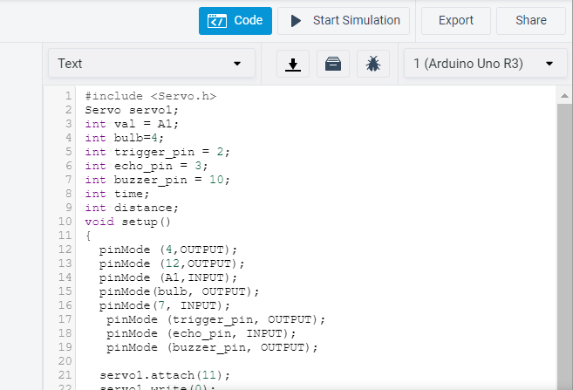

Fig: **2.4 SOFTWARE DESCRIPTION**

13

**CHAPTER – 3**

**CIRCUIT DIAGRAM AND DESCRIPTION**

**3.1 WORKING**

We have used temperature sensor, gas sensor and PIR sensor. Whenever the temperature rises more than 500C the temperature sensor that is LM35 detects it and sends the information to Arduino. Then the Arduino receives it and automatically gives the sound from the buzzer and temperature was displayed in LCD. The gas sensor is MQ2 sensor. It detects the dangerous gases like cardon monoxide, sulphur dioxide etc.., and alerts with the sound through the buzzer and when gas detects it displays as poisonous gas in the LCD. And PIR sensor sets the boundary limit area. If any person was detected in those boundaries, PIR sensor gives the information to relay actuator, thorough the relay actuator the bulb will glows and displays as danger zone in LCD if any person was detected. If no person was detected, it displays as safe zone. The working of Industrial automation using Arduino

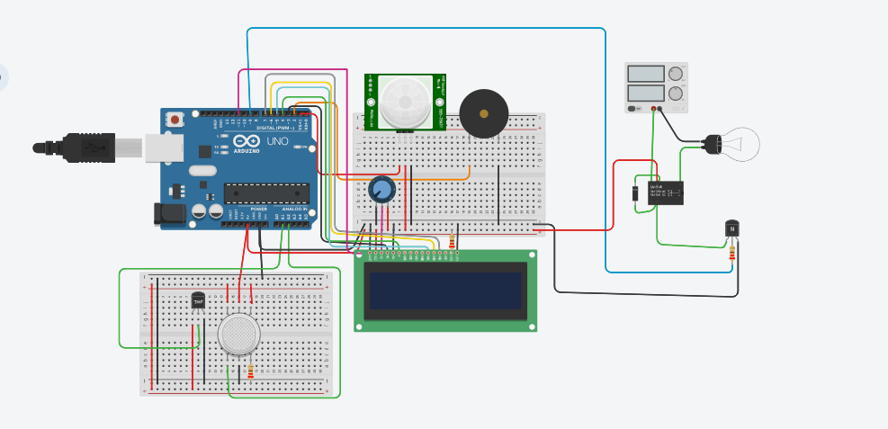

**3.2 Experimental result**

14

This SMART MONITERING SYSTEM and it was user friendly and cost effective.

STEP 1:

PIR sensor detects the motion of person near the system and get the display on LCD and also there is the glow of bulb.

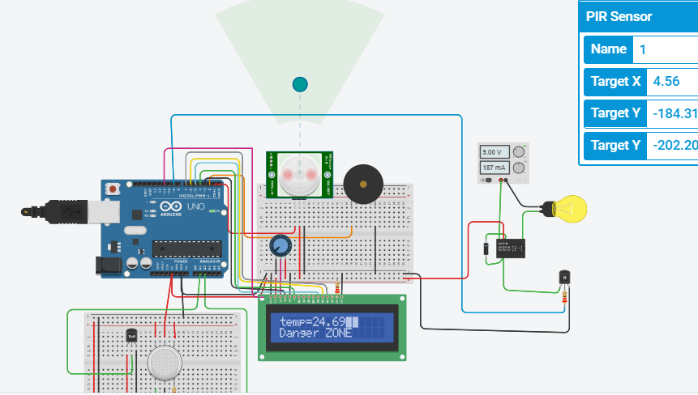

STEP 2 :

Temperature sensor detects the level of temperature int flame which is displayed on LCD. If the tempaerature exceeds to the set limit buzzer activates and alerts.

15

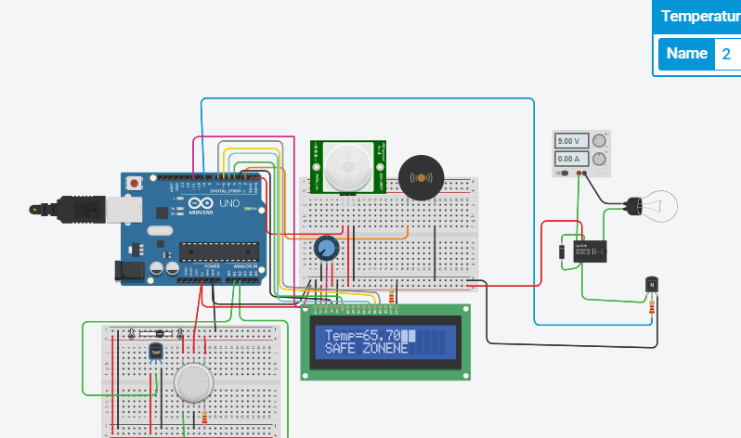

STEP 3:

Gas sensor detects the gas released and gives display on LCD. Also the buzzer activates and alerts.

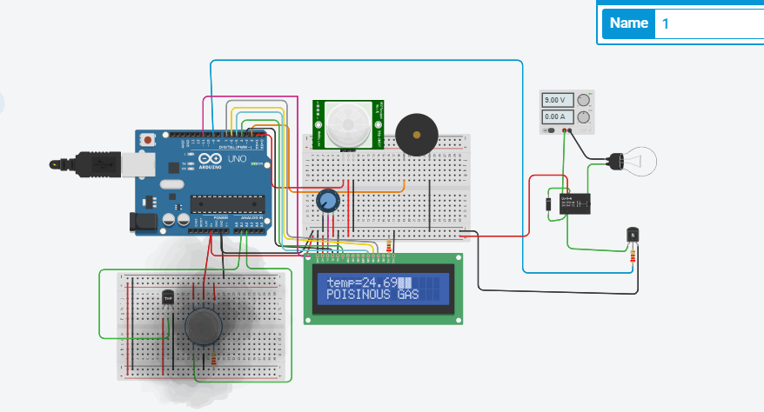

**3.3 ADVANTAGES**

* Increases convenience through PIR sensor to detect person
* Less man power.
* Contributes to economy

16

* new devices and appliances.

Improved environment (i.e., no overflowing bins and less unpleasant odors)

**3.4 DISADVANTAGES**

* Equipment and installation cost. (System requires more number of waste bins for separate waste collection as per population in the city. This results into high initial cost due to expensive. Sensor nodes used in the dustbins have limited memory size.
* Human errors.
* Reliability.
* System compatibility.

**CHAPTER – 4**

**4.1 CONCLUSION**

Smart monitering system is an intelligent management system. Monitoring the fullness of dangers through the use of sensors, it is possible to achieve a more efficient system than the current existing. Our idea of “Smart monitering system”, mainly concentrates on Monitoring thedangers or any disturbances caused like increase in excess of temp, poisinous gas detection and also identifying the person coming near the dangers.. The proposed idea can be implemented for smart cities where the manufacturing industries would increase in future. This device can be implemented in a diserable industry, for benifial purpose.

**4.2 FUTURE ENHANCEMENTS:**

There are several future works and improvements for the proposed system,

* Change the system of user’s authentication and atomic lock of the device which woukd help in new attachments of ideas and technology.
* Concept of safetiness to the labour that would encourage the involvement of the residents or the end users making the idea successful and helping to achieve joined efforts
* Having case study or data analytics on the type and safety measures taken in this project through the present technology, is predictable and removing the dependency on human efforts .
* Improving graphical interfaces for the Server and complete Android applications has possibility of extending the system adding other use cases and applications for smart cities.
* Moreover, the proposed solution is flexible and have a good maintainance with respect to the determination of expecting the seriousness and safetiness of the labour. Therefore, future works can be made in the study of models that offer the best results in terms of decision-making

**BIBLIOGRAPHY**

[1] Longhi, S ., Marzioni , D., Alidori , E., Buo , G. D., prist , M., Grisostomi , M., Pirro , M . Solid Waste management Architecture using Wireless Sensor Network Technology in New Technologies , Mobility and Security (NTMS) , 5th International Conference , IEEE, pp. 1-5,2007.

[2] Thakker , S., Narayanamoorthi , R., Smart and Wireless Waste Management , in Innovation in Information , Embedded and communication systems (ICIIECS) , pp. 1-4, 2009.

[3] Al Mamun , M. A., Hannan, M. A ., Hussian, A ,Real time Solid Waste Bin Monitoring System Framework using Wireless Sensor Network in Electronics, Information and Communications (ICEIC) , International conference, IEEE, pp.1-2,2010.

[4] Chowdary. B., chowdary M. u, RFID based Real Time Smart Waste Management System in Telecommunication Networks Applications Conference, IEEE, pp-175-1800, 2011.

[5] City Garbage collection indicator using RF (Zigbee) and GSM technology.

[6] Meghana K C,Dr. K R Nataraj,” IOT Based Intelligent Bin for Smart Cities.”, International Journal on Recent and Innovation Trends in Computing and Communication ISSN: 2321-8169 Volume: 4 Issue: 5 IJRITCC— May 2012

[7] ArkadyZaslavsky, DimitriosGeorgakopoulos, ”Internet of Things: Challenges and State-of-the-art solutions in Internet-scale Sensor Information Management and Mobile Analytics”,2014 16th IEEE International Conference on Mobile Data Management.

**APPENDIX**

**#include<LiquidCrystal.h>**

**LiquidCrystal lcd(3,4,5,6,7,11);**

**int fre =2000;**

**int z=0;**

**int gas=100;**

**void setup()**

**{**

**lcd.begin(16,2);**

**pinMode(A2,INPUT);**

**pinMode(2,OUTPUT);**

**pinMode(9,OUTPUT);**

**pinMode(1,INPUT);**

**}**

**void loop()**

**{**

**int y=analogRead(A1);**

**int x=digitalRead(1);**

**int z=analogRead(A2);**

**float temp=(y\*0.4882)-50;**

**if (x==HIGH)**

**{**

**lcd.setCursor(0,1);**

**lcd.print("Danger ZONE");**

**19**

**delay(2000);**

**lcd.clear();**

**digitalWrite(9,HIGH);**

**}**

**else**

**{**

**lcd.setCursor(0,1);**

**lcd.print("SAFE ZONE");**

**delay(2000);**

**lcd.clear();**

**digitalWrite(9,LOW);**

**}**

**if(z>gas)**

**{**

**lcd.clear();**

**lcd.setCursor(0,0);**

**lcd.print("POISONOUS GASES");**

**tone(2,523,1000);**

**}**

**else**

**{**

**lcd.setCursor(0,0);**

**lcd.print("NO GASES");**

**}**

**if(temp>=50)**

**{**

**lcd.setCursor(0,0);**

**lcd.print("Temp=");**

**lcd.println(temp);**

**tone(2,fre);**

**}**

**else**

**{**

**lcd.setCursor(0,0);**

**lcd.print("temp=");**

**lcd.println(temp);**

**}**

**if (temp>=50&&z>gas&&x==HIGH)**

**{**

**lcd.setCursor(0,1);**

**lcd.print("Temp=");**

**lcd.println(temp);**

**lcd.setCursor(0,2);**

**lcd.print("POISONOUS GASES");**

**lcd.setCursor(0,0);**

**lcd.print("DANGER ZONE");**

**tone(2,fre);**

**}**

**}**

**21**